IO3 – A3 - Piloting
FyG Consultores

Report on Platform Piloting
The content of this publication represents the views of the author only and is his/her sole responsibility. The European Commission does not accept any responsibility for use that may be made of the information it contains.

Contents
1. Methodology 2
2. Responses of the piloting 2
3. Conclusions: 9
Annex 1 – Dissemination material 9
Annex 2 – Photos of the sessions 9

Methodology
FyG conducted one seminar session that took place on Zoom platform on 30th September 2021. The duration session was approximately of 1h.
8 participants attended the sessions and all of them completed the evaluation questionnaire.
The teachers, educators and psychologists who helped us to do this testing were previously contacted by telephone and email. All of them belong to the world of education or psychology and have experience in dealing with adolescents at risk of dropping out of school.
For this, we presented the project and its objectives. Then, we presented the modules and the platform created to help educators. It was the educators themselves who registered, explored the platform and finally answered the survey by providing feedback.

Responses of the piloting
The questionnaire reunited a total of 8 answers from the participants.
In the first graph we can see that the majority of the respondents are teachers or educators. This majority comprises 57.1%. On the other hand, we can see that 28.6% are psychologists and, finally, 14.3% are social workers.
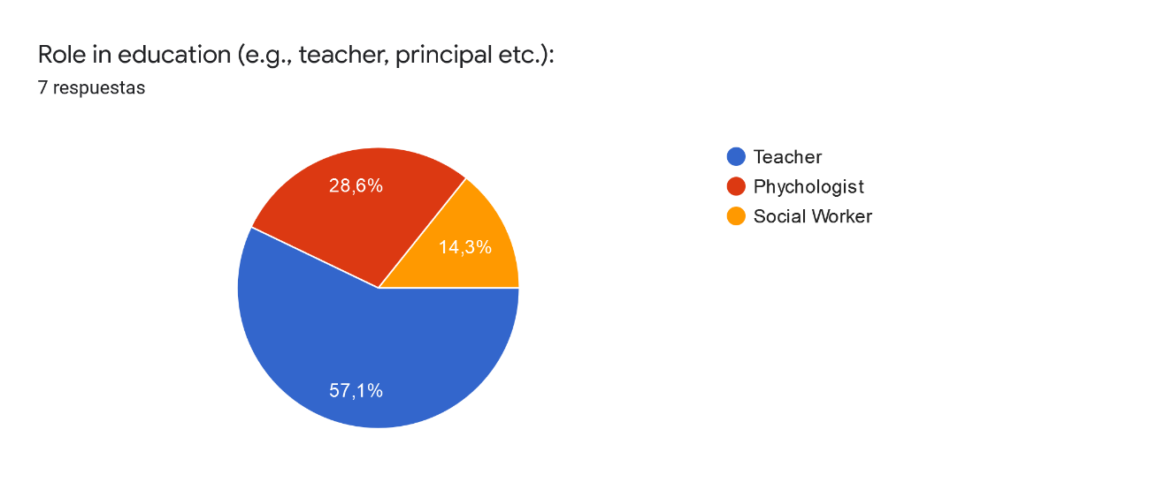
In the next question, all participants answered question 1. Has your ability to identify pupils at risk of dropping out changed after participating in the seminar ?

All respondents answered yes.
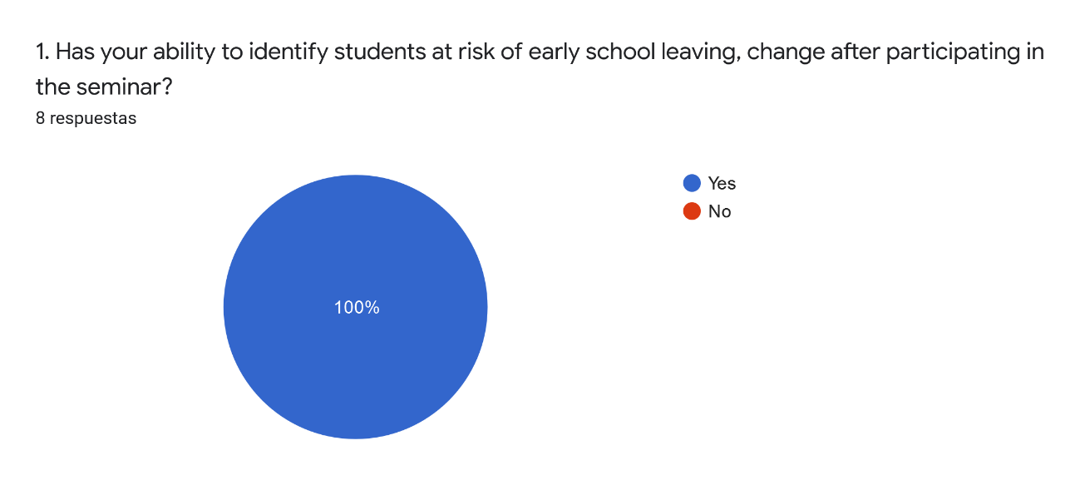
Related to the previous graph and question, respondents answered:
- Yes, my ability to observe whether someone is at risk of dropping out of school has increased.
- I can now understand the situations that some students may be in.
- I have new skills to be able to do so.
- It has helped me to see a new way of teaching and learning.
- Now i have more knowledge and experience and I will be more aware of that
- I have more knowledge now about that.

In question 2, respondents answered the following question:
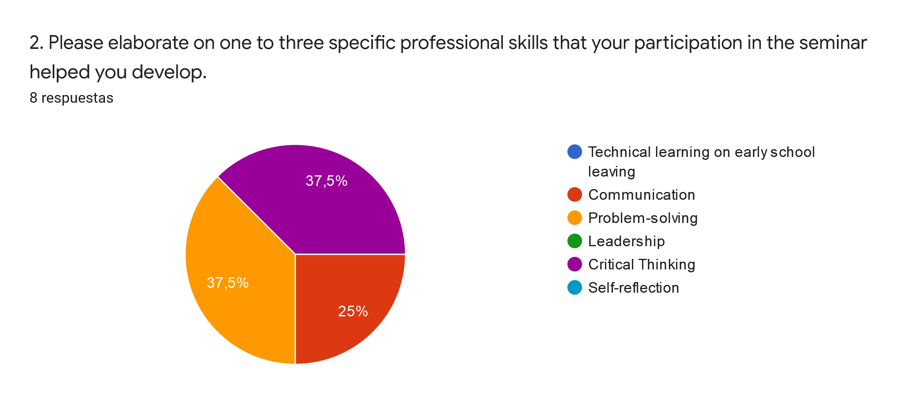
The responses to this form were varied. Communication was the most voted option after problem-solving and critical thinking.
In the third question: Did you consider that the titles of the online modules are according with their actual content? All respondents answered yes to the question.
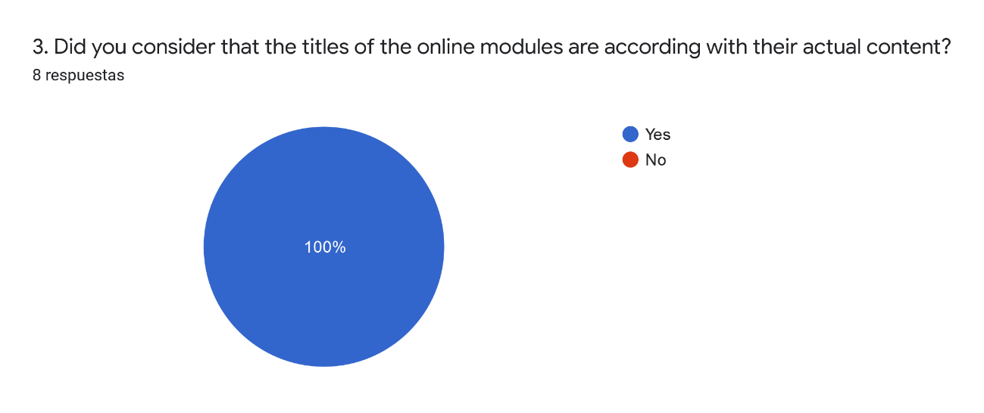
In the fourth question, participants responded openly to: Which parts of the course (e.g. research papers, reports, guides, tools, case studies) helped you learn the most?
The answers were as follows:
- The guides and the case studies
- Tools
- Case studies and tools
- Research papers and case studies
- The most useful jave been the guides and case studies because they are very indicative
- Research papers, are of high quality
- The case studies

Question 5 shows the different methods used by each of the respondents.
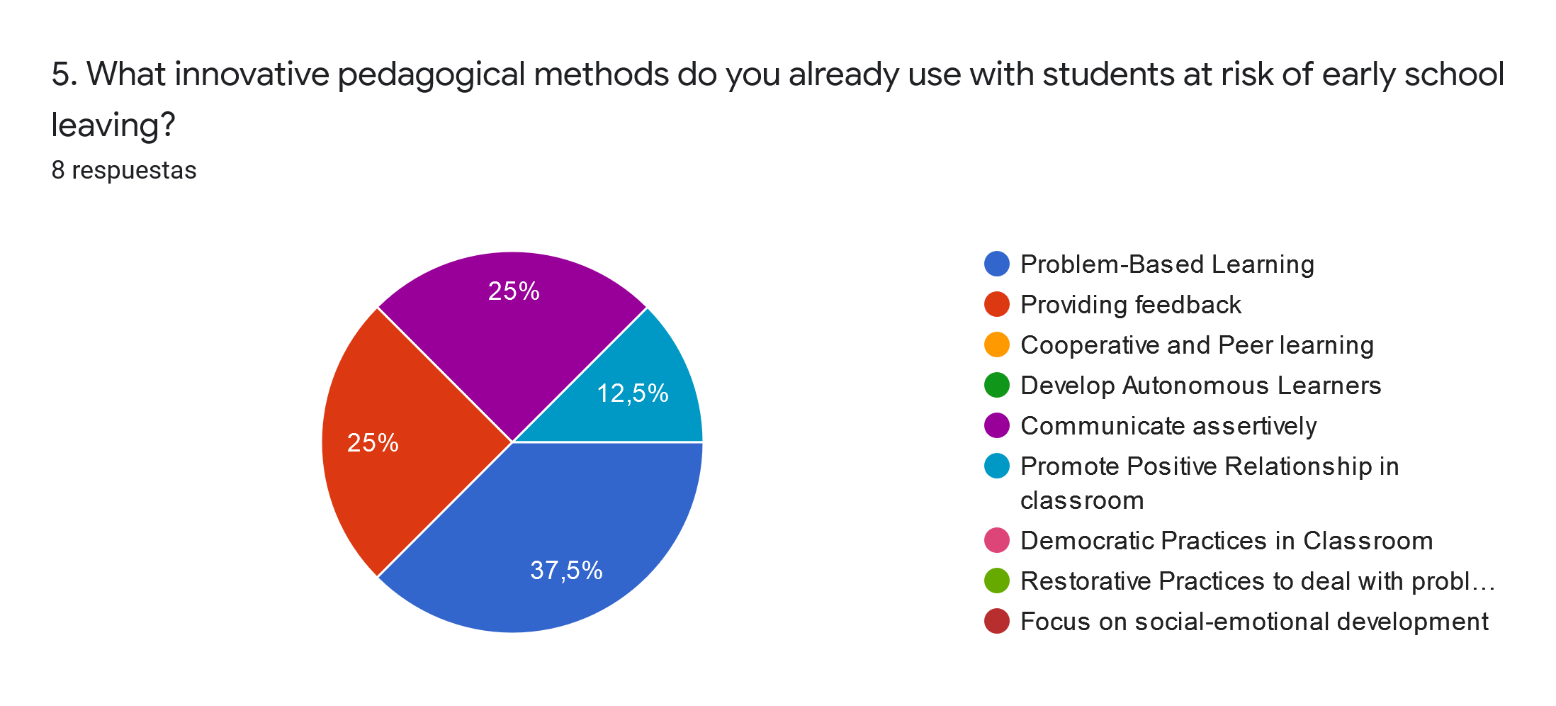
Among the most voted, we can find problem-based learning with 37.5%, providing feedback and communicate assertively, both with 25% of the total responses and promote positive relationships in classroom with 12.5%.

In the next question, the participants were asked which pedagogical method they used. The answers were as follows:
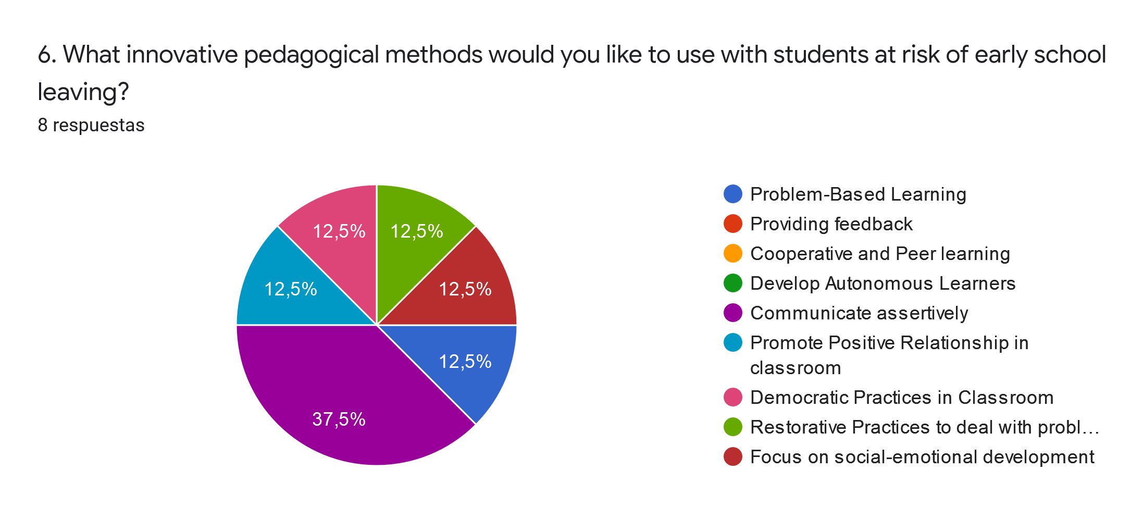

The most voted answers were: Democratic Practices in Classroom, Promote Positive Relationship in classroom, Restorative Practices to deal with problematic behaviour, Focus on social- emotional development, problem based learning and communicate assertively. The last one with 37,5% of the total votes.

Following the survey, participants answered some questions related to the platform.

In question 7, 37.5% of respondents said that accessibility and interactivity were among the features they liked the most. The remaining 25% of the participants answered that it was the 'user-friendliness' feature.
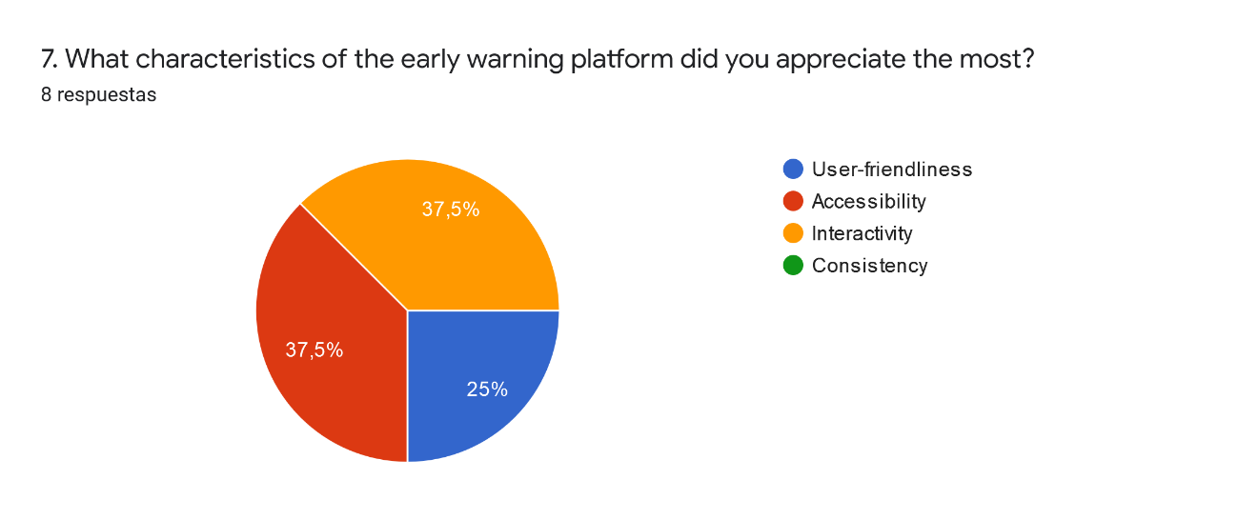

In the next question, participants responded openly to the question: How did the Massive Open Online Courses (MOOCs) format of the learning material help you expand your knowledge on innovative pedagogical methodologies?
The responses collected were:
- I can now understand certain situations much better and act better.
- It is very interactive and visual so I can better understand some topics and apply them with the students.
- The amount of definitions and examples were very helpful
- New ways to approach students and be more assertive when talking to them
- The MOOCs of the learning material helped me to broaden my knowledge of innovative pedagogical methodologies because it is a methodology that I did not know before.
- through the proposed activities I have learnt new tools
- It is really useful and it's very interactive and dynamic
- I think the format it's really nice to learn

In the penultimate question, respondents replied to:
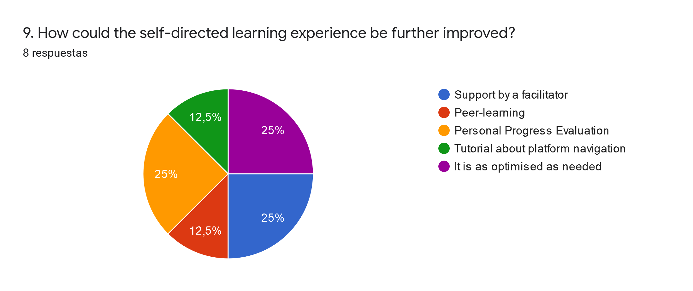

In this graph it can be seen that half of the participants responded with 25% of votes in each of the answers to:
- Support by a facilitator
- It is optimised as needed
- Personal Progress Evaluation

And with 12.5% each response to:
- Tutorial about platform navigation
- Peer-learning

Finally, the respondents answered the last question : Do you have any specific recommendations for improving the Early Warning Platform ?
- Being able to talk to other educators on the same platform to help each other.
- No, I think it is quite good
- No, it looks really good!
- No, thank you! The platform is really elaborated and easy to use!
- It would be better if it is supported by a facilitator
- No

Conclusions:
All the answers obtained from this questionnaire help to improve the project platform to prevent school dropout. Overall, the opinions are positive and show that the platform has helped them in their professional life. The answers provided in the last question give the project and the consortium ideas on how and where to improve. Although all opinions are positive, the ideas of being helped by a facilitator or even creating a network of teachers, educators, psychologists, or social workers to help each other can be ideas that can be implemented in the future on the platform.

Annex 1 – Dissemination material

Annex 2 – Photos of the sessions
